Final Report

Testbench Architecture
Below is the high level block diagram of tb_top.sv
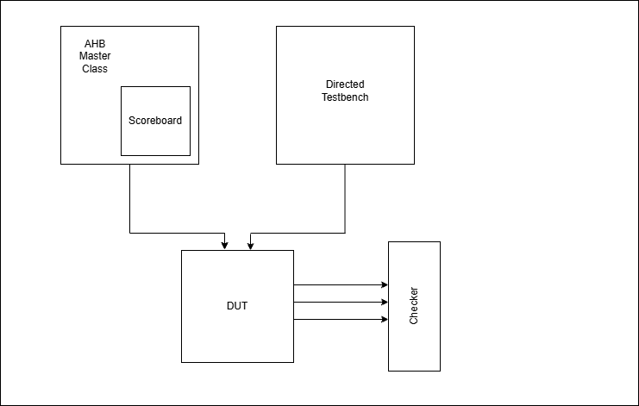

Test Plan Summary

Test Plan Summary

Overview
Our verification plan validates the functional correctness and AHB3-Lite protocol compliance of the memory slave using directed tests, corner-case scenarios, and constrained-random testing.

Basic Transfer Verification
Single transfer operations are tested for byte, halfword, and word sizes in both read and write modes. These tests ensure correct byte-level write masking, proper data storage, and accurate readback without affecting adjacent memory locations.

Burst and Address Generation
Burst operations including INCR4, INCR8, INCR16, WRAP4, and WRAP8 are verified. These tests confirm correct address incrementing, proper burst sequencing, and correct wrap-around behavior within defined boundaries without illegal address generation.

Protocol Compliance and Control Behavior
Key AHB protocol behaviors are validated, including:
- IDLE transfers (no memory update)
- Back-to-back transfers (continuous operation without IDLE gaps)
- HREADY = 0 wait-state handling, ensuring stall and resume behavior preserves transfer integrity

Read-After-Write (RAW) Behavior
Immediate read-after-write scenarios are tested to verify correct data visibility and ensure no contention or delay in updating memory values.

Random Stress Testing
A constrained-random test of 10,000 transactions is executed to stress the design, uncover corner cases, and ensure robustness under unpredictable traffic conditions.

Coverage and Completeness Goals
Functional and cross coverage ensures full protocol exploration:
- All possible HTRANS, HBURST, HSIZE, HWRITE values exercised
- Address space divided into bins for full memory coverage
- Coverage of HREADY stalls and HRESP error conditions
- Cross coverage of HBURST × HWRITE, HSIZE × HWRITE, HTRANS × HREADY

Pass Criteria
- All directed tests pass
- Zero scoreboard mismatches
- Random testing completes without errors
- Full coverage closure achieved across all defined bins and crosses

Assertion List

a_write_read_correctness
Category: Functional

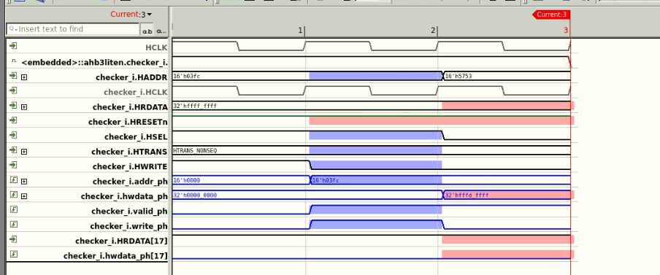

a_no_change_without_write
Category: Functional
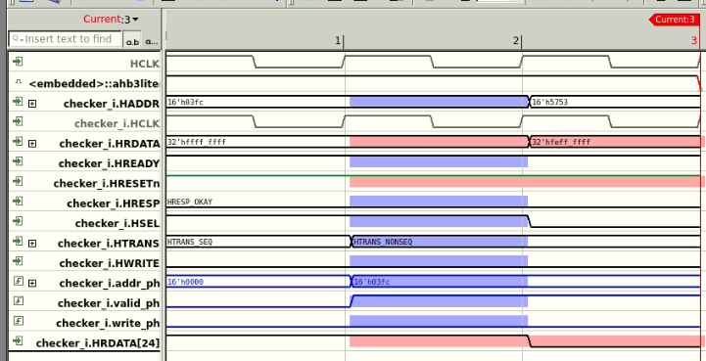

a_latest_write_wins
Category: Functional

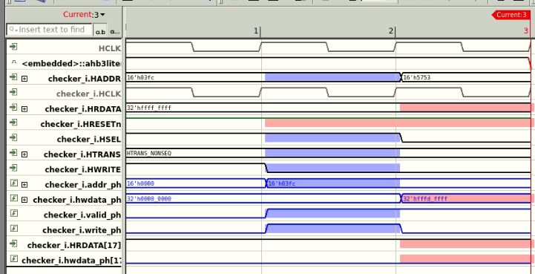

a_word_write_atomic
Category: Functional
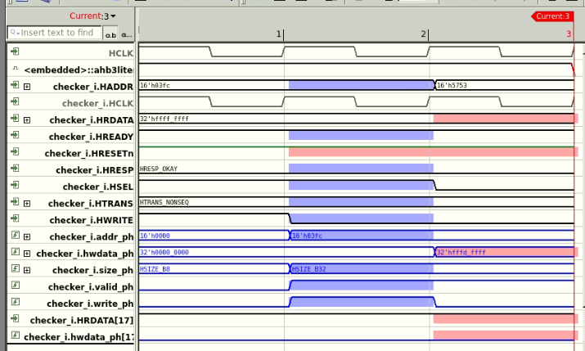

a_no_mem_change_on_read
Category: Functional
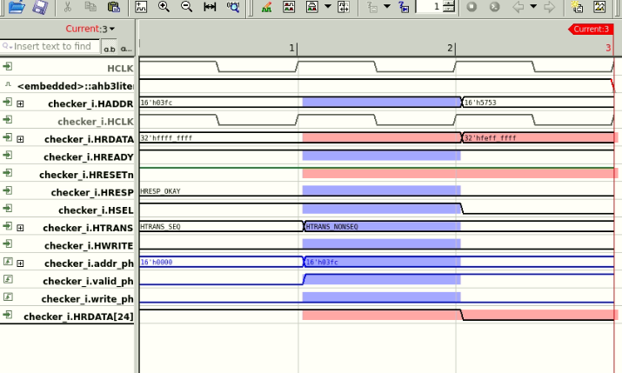

a_read_after_write
Category: Functional

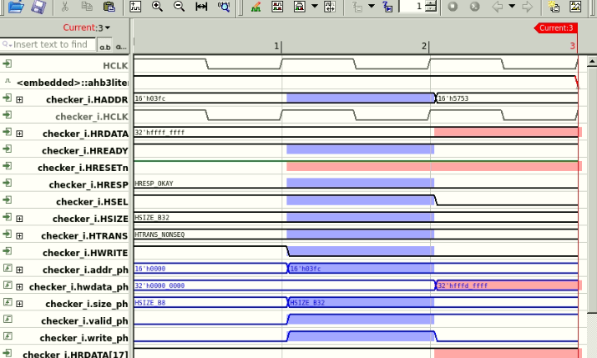

a_pipeline_rw_ordering
Category: Pipeline

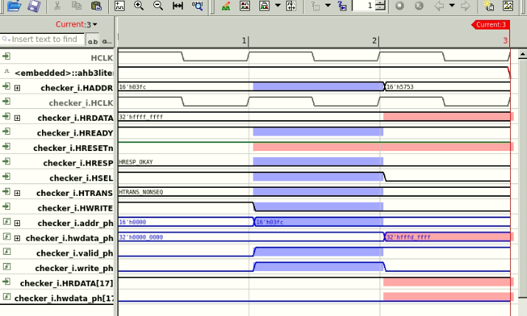

a_byte_write_targeted
Category: Masking

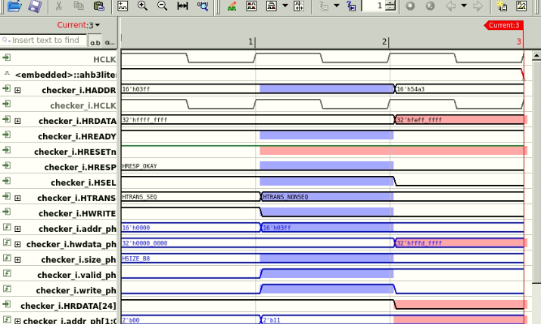

a_byte_write_no_corrupt
Category: Masking

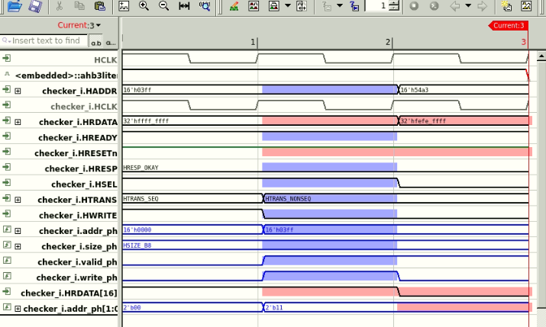

a_hword_write_targeted
Category: Masking

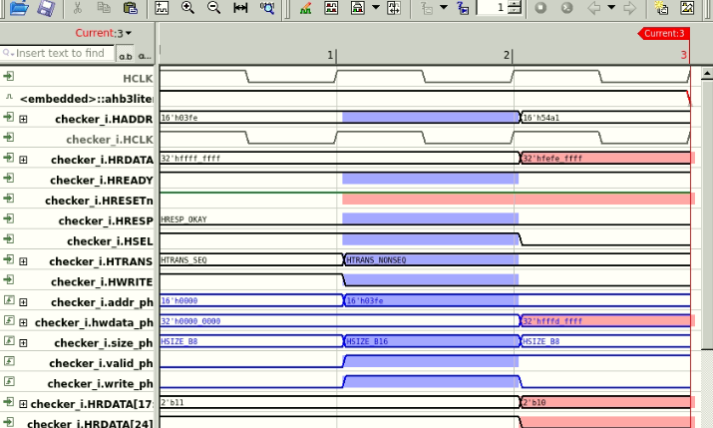

a_hword_write_no_corrupt
Category: Masking

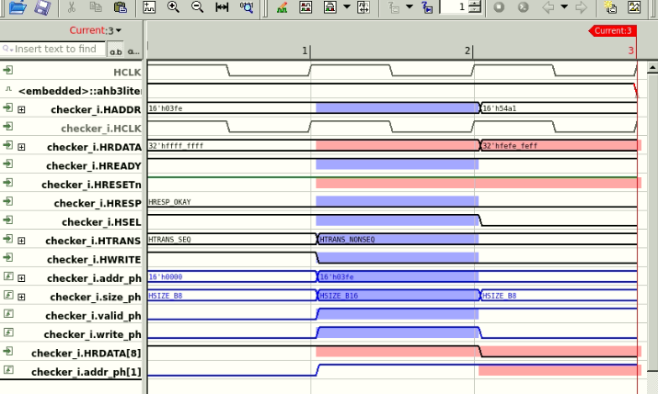

a_consec_reads_same_data
Category: Read Stability



Bugs found

Bug Description Caught By Assertion
Memory write not persistent a_write_read_correctness
Memory changes without write a_no_change_without_write
Read has side effects on memory a_no_mem_change_on_read
Back-to-back write ordering wrong a_latest_write_wins
Read-after-write returns stale data a_read_after_write
Byte lane targeting wrong a_byte_write_targeted
Byte write corrupts adjacent bytes a_byte_write_no_corrupt
Half-word targeting wrong a_hword_write_targeted
Half-word write corrupts other half-word a_hword_write_no_corrupt
Word write not atomic (partial update) a_word_write_atomic
Pipeline read-after-write ordering wrong a_pipeline_rw_ordering
Consecutive reads returning different data a_consec_reads_same_data

Coverage Results
IMC RESULTS BEFORE MODIFICATIONS:
Total Coverage: 77.88%
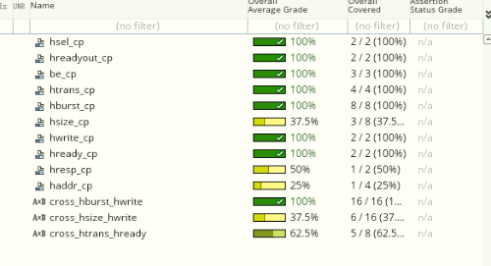
IMC RESULTS AFTER MODIFICATIONS:
Total Coverage: 97.12%
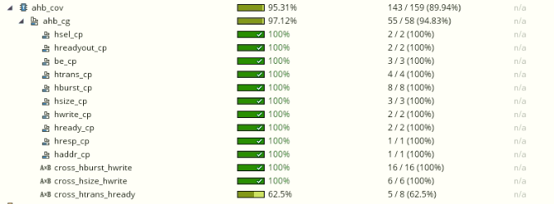
- In hsize_cp, bins for 64-bits and above are ignored because the DUT is designed with a 32-bit data bus (HDATA_SIZE = 32). Therefore, transfers larger than 32 bits are not supported by the architecture and do not affect functional behavior.
- In hresp_cp, the HRESP_ERROR bin is ignored because the DUT implementation always generates HRESP_OKAY under all transaction conditions. Including this bin results in an unreachable coverage point.
- In haddr_cp, the higher address bins (above 1Kb) are ignored because the AHB master is constrained to generate addresses within a 1 KB range. As a result, the address is never generated outside this region.
- Ignoring bins from hsize_cp consequently reduces the coverage space of cross_hsize_hwrite, and hence higher cross coverage.

The reduced coverage in the cross_htrans_hready is because when HREADY is low, BUSY, NONSEQ, or SEQ cannot happen. Surprises and ImprovementsT

